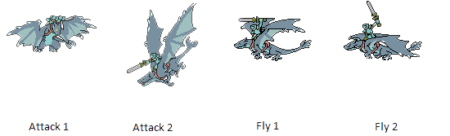
Game of Towers

Game Design Document
Version 0.1
23 April 2014
Table of Contents

1Design History 3
2Team Personnel 4
3Section I - Game Overview 5
3.1Game Concept 5
3.2Genre 5
3.3Target Audience 5
3.4Game Flow Summary 5
3.5Look and Feel 5
3.6Project scope 5
3.6.1Environments 5
3.6.2Levels 6
3.6.3Characters 6
3.6.4 Projectiles 8
3.6.5Power-Ups 9
4Section II - Gameplay and Mechanics 9
4.1Gameplay 9
4.1.1Mission/challenge Structure 9
4.1.2Objectives 9
5Mechanics 10
5.1Movement 10
5.1.1General Movement 10
5.2Win Conditions 10
5.3Loss Condition 10
6Section III – Interface 10
6.1Control System 10
Mouse Controls 10
6.2Menu and General Game Usage 10
6.2.1Splash Screen 10
6.2.2Loss Screen 11

Design History

Changes | Date
Original Draft | 9 September 2013

Team Personnel

Neilson Leslie | Programmer
Brandon Coulthard | Programmer
Jonathan MacLachlan | Programmer

Section I - Game Overview

Game Concept
The game “Game of Towers” is a simple tower defense game. The player will try to eliminate waves of “invaders” and stop them from destroying his castle/tower.
Each level has a single waves of enemies with each level introducing a new enemy or combination of previously encountered enemies. As the player is able to accomplish the task of defeating each wave, the next wave becomes more difficult. Instead of being stationary objects, various enemies have special attributes about them. Some enemies move faster than others, some requires to be hit by the player’s more than once before that enemy is defeated. The projectiles from the enemies are also destroyable by shooting before they hit the castle/tower

Genre
The game genre is an action game.

Target Audience
The audience that this game will appeal to will be all ages and test the player visual and reflexes while employing a fun factor and imaginative immersion.

Game Flow Summary
The player progress through each level. To progress to the next level, the player must destroy all enemies for that level. There is no limit on levels, simply play until you get a game over.

Look and Feel
The plot is that the player is a Master Wizard and the player sole goal is to defend the castle/tower from an onslaught of enemy invaders. As the user/player you have to guide the direction of the Wizard’s attack to stop the invader’s enemy fire as well as eliminating the invaders themselves. This is a battle for the survival of your kingdom and you are their last hope. Prove your mettle and show those invaders that the Kingdom of Fiore is strong and will not be defeated. Beat the mission and come home a hero!!

Project scope

Environments
The environment will never change. The terrain will be constant and the position of the castle/tower will always be in the center.

Location – The Kingdom of Fiore
The Kingdom of Fiore will be what the player is defending. The Castle/Tower has a total of 50 hit points in total and as enemy projectiles hit the castle, health depleted accord to the damage deliver by the respective projectile. If Castle’s hit points reach zero the game is over.

Levels

(come back to this once level calculations are defined)

Characters
The characters within the game is the avatar representing the player and the various enemy types. The player is represented by a wizard-type sprite standing in the center tower of the castle. The enemies vary in type and colour to quickly identify their differences in abilities and attributes. Each level introduces a new enemy to utilize in combination with previously encountered enemies.

Wizard
The Wizard, “Joffrey” will be the player controlled avatar used to defend the castle and stop the invaders. The wizard will be restricted to the Y axis and X axis. Motion is positive and negative rotation movement about the Y axis.

The Wizard:

Enemies
We have designed three kinds of enemies that we have designed for this game. There are three types of enemies; the airship, the siege weapon and the dragon-type beast.
Each of the types of enemies have three levels with each level stronger than its predecessor.

The Airship:
Lvl 1: Lvl 2:

Airship #1:
Attack every 3 seconds. Drop a single bomb vertically. A single bomb deals a damage of 5 points. Move at a constant speed across the screen. This airship has no armour and a health total of 12 points.

Airship #2:
Attack every 3 seconds. Drop two bombs vertically. A single bomb deals a damage of 5 points. Move at a constant speed across the screen. This version of the airship has an armour of 4 points and a health total of 20 points.

Siege Weapon:

Lvl 1: Lvl 2:

Siege Weapon #1:
Rolls on to the hillside to attack. The siege weapon attacks with a single bolt every 5 seconds. The damage received from a single bolt is 4 points. This siege weapon has no armour and a health total of 10 points.

Siege Weapon #2:
Rolls on to the hillside to attack. The siege weapon attacks with two bolts every 5 seconds. The damage received from a single bolt is 4 points. This siege weapon has no armour and a health total of 15 points.

Dragon-type beast:

Lvl 1:
Lvl 2:
(need image like above but in a different colour)

Drake:
The drake flies in from the side and can attack every 2 seconds. A single fireball is fired diagonally. The total damage that can be dealt is 10 points. A player’s counterattack can reduce the amount of damage until all is blocked and stop the attack. The drake has an armour defense of 5 points and a total health of 15 points.

Wyvern:
The wyvern flies in from the side and can attack every 2 seconds. A single fireball is fired diagonally. The total damage that can be dealt is 10 points. A player’s counterattack can reduce the amount of damage until all is blocked and stop the attack. The wyvern has an armour defense of 5 points and a total health of 15 points.

Projectiles
There are four types of projectiles in Game of Towers, three of which are enemy attacks and one is the player’s defensive attack.
Magic Orb Attack: The wizard shoots this projectile at the enemies in order to defend the castle.

Bombs: Ships drop bombs vertically down onto the castle which explode upon impact.

Siege Weapon Bolts: The siege weapons fire bolts at rapid pace at the castle. They do less damage than bombs or fireballs but fire at a much quicker pace.

Fireballs: Dragons shoot fireballs that deal a high amount of damage that take multiple hits to destroy.

Power-Ups

Ships can drop a power up at random points when they are destroyed which give the player either a damage increaser, or a health restore power up.

Damage Increase:

Increase player damage for 15 seconds by 5 points
Damage Power-Up:

Health Restore:

Will increase castle health by 10 points but won’t increase it beyond the castle health capacity.
Health Power-Up:

Section II - Gameplay and Mechanics

Gameplay

Mission/challenge Structure
The game will take place at Castle Heimdell in the Kingdom of Fiore. The invading forces have made it within the kingdom’s borders and lands and are ready to lay siege to the Castle. As the wizard King, Joffrey, you will fight from the battlement of your tallest tower and defend the Castle from the onslaught. The challenge is to keep the health of your Castle above zero at all times. The health from the previous level carries forward into the next level.

Objectives
The objectives of the game are:
- Successfully defend the Castle from each wave of invaders.
- Armed with a powerful spells, the wizard Joffrey defend and fight off the attacks by skillfully destroy the projectiles as well as the enemies.
- Destroy all enemies for to complete each level and progress to the next level.
- Don’t let the Castle’s hit points reach zero.

Mechanics

Movement

General Movement
The general movement is the position the wizard is looking at but neither his X value or Y value ever change. You use the mouse to point where the wizard is looking at and his sprite matches the direction the mouse is at.

Win Conditions
The player tries to get the best high score possible to be recognized on the leader board. The leader board records the total time the player survived the game and is placed on the leader board rankings. Complete the game as fast as possible.

Loss Condition
The castle’s health reaches 0 the game has ended and the player has the option to replay the game or quit. A game over message will be displayed.

Section III – Interface

Control System

Mouse Controls
The mouse controls the direction and angle the wizard will target the enemy at and the left button fires the wizards spell. Using the right click to activate the power up in your inventory if you have one.

Menu and General Game Usage

Splash Screen
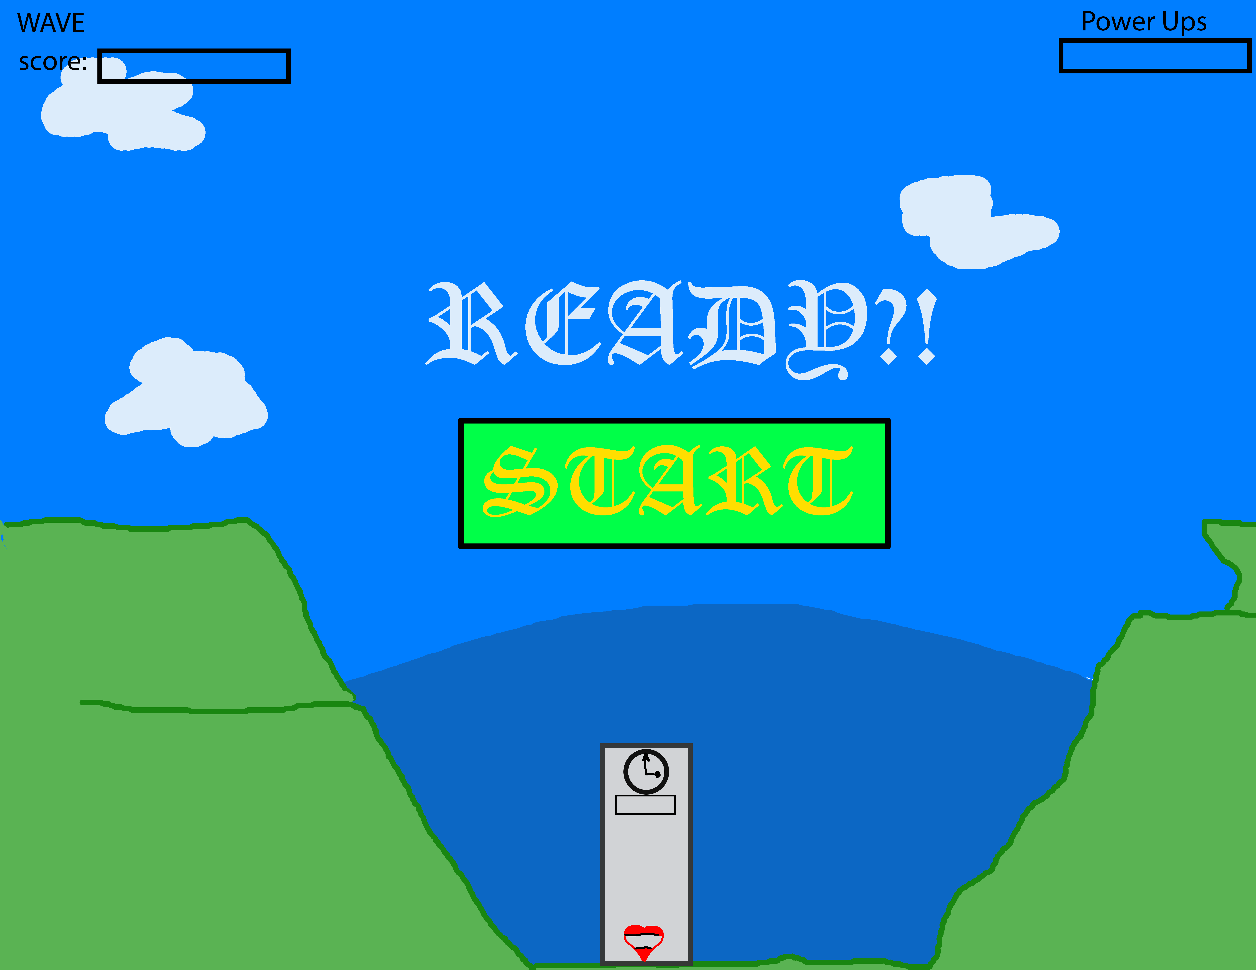
Shows a picture of the castle you are defending.

Loss Screen
If at all through the game any loss condition is achieved a screen will pop up with two buttons: Retry or Quit. Retry will start that level from the first wave.
